**Name: Lawrence M. Alba Subject: Intro to HCI**

**Block: 1 Instructor: Ma’am Rochelle Lanto**

**Output**

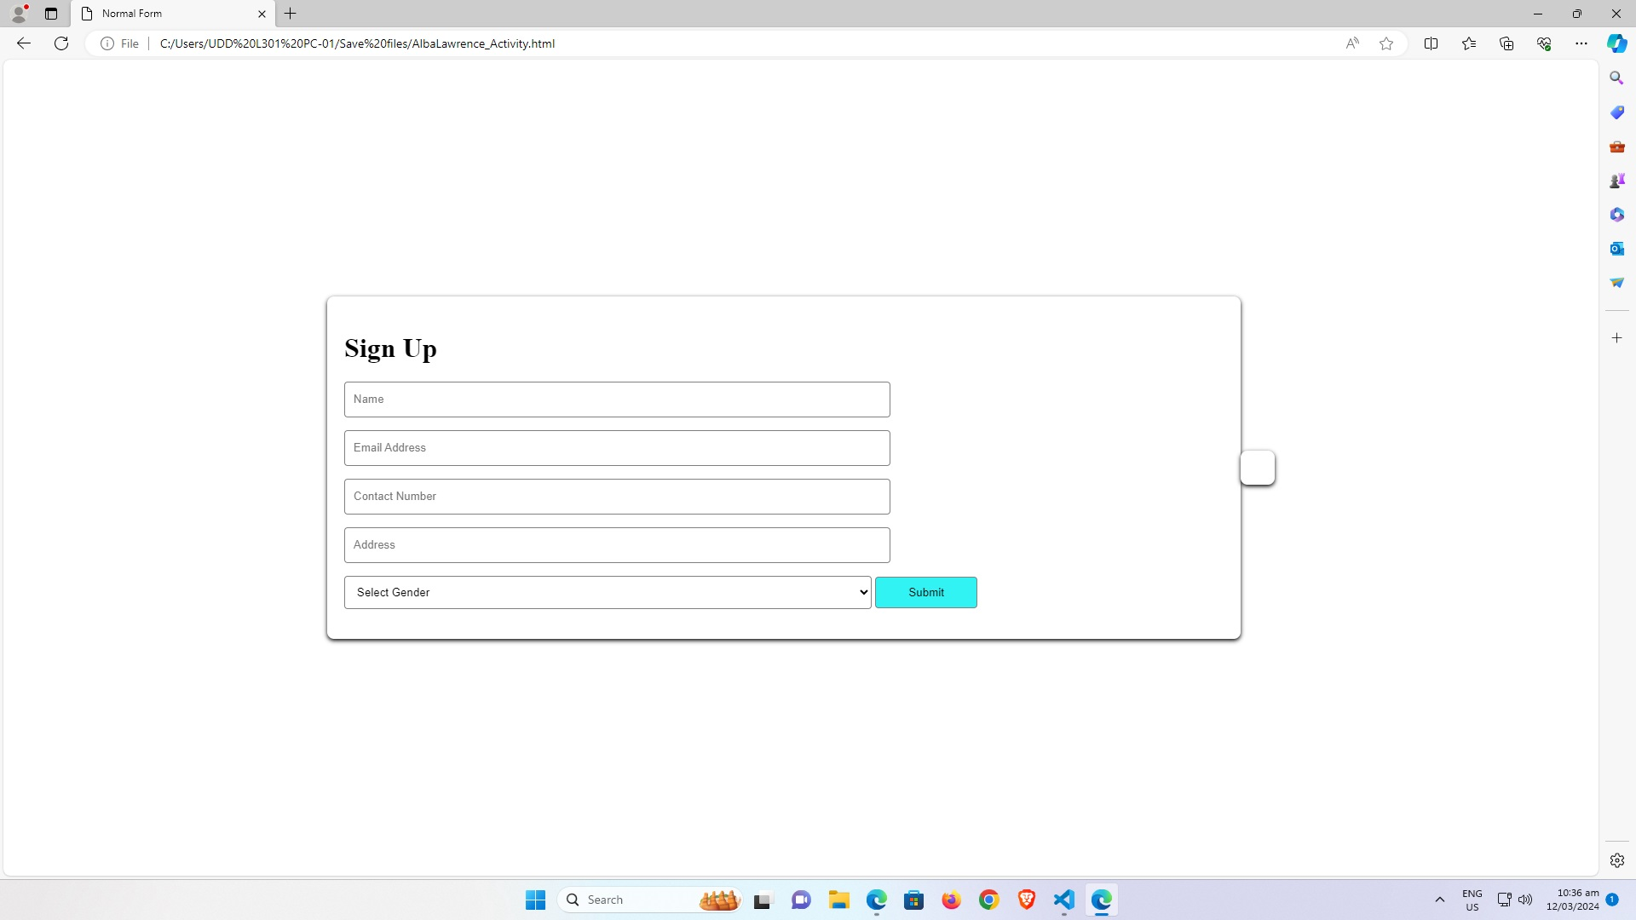

**HTML and CSS Code**

